OES Personal Protective Equipment (PPE) Plan

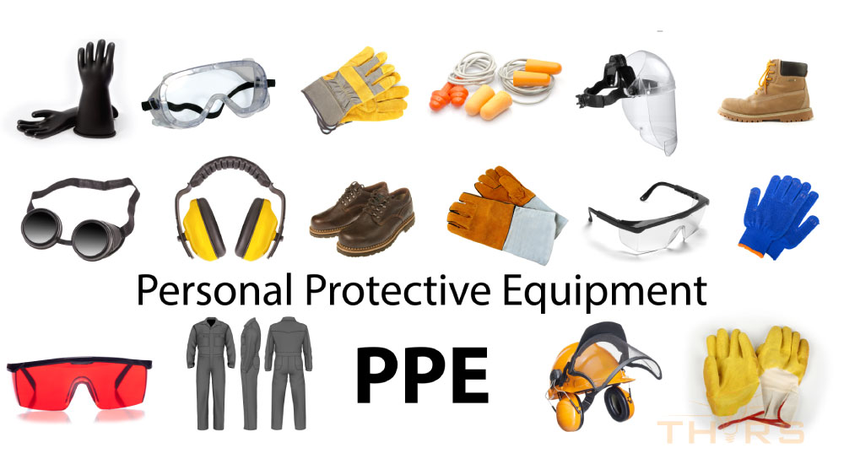

Contents

PURPOSE AND SCOPE 3

DEFINITIONS 3

PROGRAM RESPONSIBILITIES 4

PPE SELECTION 5

TRAINING 10

POINT OF CONTACT 10

OES Personal Protective Equipment Plan

1.0 Purpose and Scope
The purpose of this written plan is to help identify the appropriate protective equipment for the tasks that are being conducted across campus. Additionally, a Safety Task Analysis (STA), also known as a Job Hazard Analysis (JHA), determines the type of protective equipment that should be worn for specific tasks (see the STA written plan for more information). Personal protective equipment, commonly referred to as “PPE”, is equipment worn to protect against simple workplace hazards. Examples of PPE are gloves, safety toe boots and shoes, safety glasses, earplugs and earmuffs, hard hats, respirators, and full body suits.
It is the goal of Clemson University’s (CU) OES department to identify hazards within the workplace and provide protection for all CU faculty, staff, and students, and to ensure compliance with all applicable federal, state regulations concerning the selection, use, and maintenance of PPE.
Whenever possible, hazards will be eliminated from the workplace by engineering, work practice, or administrative controls. When this is not possible, or those controls do not provide enough protection, Clemson will provide PPE to employees.

2.0 Definitions
Eye/Face Protection - Equipment designed to provide protection to the face and eyes during exposure to such hazards as flying particles, molten metal or sparks, liquid chemicals, acids or caustic liquids, or potentially injurious light radiation (i.e., lasers, welding, etc.)
Foot Protection - Equipment designed to provide protection to the feet and toes during exposure to situations with the potential for foot injuries such as falling or rolling objects, chemical or liquid exposures, piercing objects through the sole or uppers, and/or where the employee's feet are exposed to electrical hazards.
Hand Protection - Equipment designed to provide protection to the hands during exposures to potential hazards such as sharp objects, abrasive surfaces, temperature extremes and chemical contact. Hand protection is selected based upon the hazard and performance characteristics of the gloves.
Hazard Assessment - The process utilized to identify hazards in the workplace and to select the appropriate PPE to guard people against potential hazards.
Head Protection - Equipment designed to provide protection to the head during exposure to potential hazards such as falling objects, striking against low hanging objects, or electrical hazards.
Hearing Protection - Equipment designed to provide protection to an individual's hearing during exposure to high noise levels.
Personal Protective Equipment (PPE) - Includes all equipment designed to provide protection to the wearer from potential hazards to the eyes, face, hands, head, feet, ears, and extremities.
Respiratory Protection - Equipment designed to provide protection to the wearer from potential inhalation hazards such as vapors, mists, particulates, and gases.

3.0 Program Responsibilities
Principal Investigators (PI)/Managers/Supervisors
Management has the primary responsibility for the PPE program in their area. They are responsible for:
- Identifying hazards using STA.
- Identifying personnel under their supervision required to wear PPE.
- Providing PPE to employees free of charge.
- Training employees in the use of PPE.
- Making sure that the PPE program is followed.
- Keeping related records (test results, hazard surveys, training records, etc.).
- Requesting special exposure/health assessments from OES as necessary.
Faculty/Staff/Employees/Students
Employees are responsible for:
- Using PPE in according to their training.
- Storing, cleaning, maintaining, and protecting PPE from damage.
- Reporting any problems or malfunction with PPE to their supervisor.
- Attending training classes.
Occupational and Environmental Safety (OES)
OES is responsible for the development, implementation, and administration of the program. These responsibilities include:
- Reviewing and updating the written program as necessary.
- Conducting exposure and health hazard evaluations of a CU workplace as necessary.
- Training Supervisors on the proper use, maintenance, and storage of respirators so that they may train employees.
- Periodically auditing assessment and training records.
- Evaluating the overall effectiveness of the PPE program.

4.0 PPE Selection
Eye Protection
Faculty, staff, students, contractors, and visitors shall wear the appropriate eye and face protection when involved in activities where there is the potential for eye and face injury from:
- Handling of hot solids, liquids, or molten metals.
- Flying particles from chiseling, milling, sawing, turning, shaping, cutting, etc.
- Heat treatment, tempering, or kiln firing of any metal or other materials.
- Intense light radiation from gas or electric arc welding, glassblowing, torch brazing, oxygen cutting, laser use, etc.
Eye protection choices include the following:
Safety Glasses
Ordinary prescription glasses do not provide adequate protection. Eye protection must conform to the American National Standards Institute (ANSI), Standard Z87.1-2020. Look for this stamp on the inside of the safety glass frame. Prescription safety glasses are recommended for employees who must routinely wear safety glasses in lieu of fitting safety glasses over their personal glasses. All safety glasses shall have side shields.
Goggles
Goggles are intended for use when protection is needed against hazardous liquids or particles. Impact protection goggles which contain perforations on the sides of goggle are not to be used for hazardous liquid splash protection, therefore are not recommended. Splash goggles which contain shielded vents at the top of the goggle are appropriate for hazardous liquid splash protection and provide limited eye impact protection. Goggles only protect the eyes, offering no protection for the face and neck.
Face Shields
Full-face shields provide the face and throat partial protection from flying particles and liquid splash. For maximum protection against splash, a full-face shield must be used in combination with splash goggles. Face shields are appropriate as secondary protection when implosion or explosion hazards are present. Face shields which are contoured to protect the sides of the neck as well as frontal protection are preferred.
Eye Protection for Intense Light Sources
(Welding, gas welding, oxygen cutting, torch brazing, etc.)
The radiation produced by welding covers a broad range of the spectrum of light. Exposure to ultraviolet light (UV-B) from welding operations can cause "welders flash", a painful inflammable of the outer layer of the cornea. Arc welding or arc cutting operations, including submerged arc welding, require the use of welding helmets with an appropriate filter lens. Goggles with filter plates or tinted glass are available for glassblowing and other operations where intense light sources are encountered, including but not limited to, gas welding or oxygen cutting operations.
Spectacles with suitable filter lenses may be appropriate for light gas welding operations, torch brazing, or inspection.
Hand Protection
Employees shall use hand protection when exposed to hazards including:
- Skin absorption of harmful substances
- Lacerations
- Severe cuts
- Severe abrasions
- Punctures
- Hazardous liquid burns
- Thermal burns
- Harmful temperature extremes
Wear proper hand protection whenever the potential for contact with hazardous liquids, sharp objects, or very hot or cold materials exists. Select gloves based on the properties of the material in use, the degree of protection needed, and the nature of the work where direct contact is necessary, and dexterity is needed.
Leather gloves may be used for protection against sharp edged objects, such as picking up broken glassware or inserting glass tubes into stoppers. Always wear a cut resistant glove on the non-cutting hand when using a knife, scissors, etc.
When working at temperature extremes, use insulated gloves. Materials such as Nomex and Kevlar may be used briefly up to 1,000 ⁰F. Do not use gloves containing asbestos. Asbestos is regulated as a carcinogen under OSHA.
When considering gloves, note that glove materials will be permeated by solvents or caustics. The permeation rate varies depending on the liquid, glove material, and thickness. Double gloving is recommended when handling highly toxic or carcinogenic materials.
Finger rings can damage gloves and trap hazardous liquids against the skin.
Before each use, inspect the gloves for discoloration, punctures, and tears.
Before removal, wash gloves if the glove material is impermeable to water.
Observe any changes in glove color and texture, including hardening or softening, which may be indications of glove degradation.
Body Protection
Employees working around hazardous materials or machinery shall not wear loose clothing, jewelry, or unrestrained long hair; all of which can become ensnared in moving parts of machinery or contact hazardous liquids.
To assure that hazardous liquids or toxic dusts are not carried home with you, use disposable protective clothing, or work clothes which remain at the workplace. Tyvek coveralls can be used over clothes for protection against particles and low hazard liquids, but do not provide complete protection against liquids.
Vinyl or rubber aprons and sleeves should be used when dispensing hazardous liquids. Where contact with hazardous materials with your protective clothing is likely polyethylene-coated Tyvek or similar clothing should be used to provide additional protection. The limitations of the protective clothing must always be understood, particularly in situations where contact with the material is likely.
Employees should know the appropriate techniques for removing protective apparel, especially any that has become contaminated. Special procedures may need to be followed for cleaning and/or discarding contaminated apparel.
Hazardous liquid spills on leather clothing accessories (watchbands, shoes, belts, and such) can be especially hazardous because many hazardous liquids can be absorbed in the leather and then held close to the skin for long periods. Such items must be removed promptly and typically be discarded to prevent the possibility of hazardous liquid burns.
Foot Protection
The employer shall ensure that each affected employee uses protective footwear when working in areas where there is a danger of foot injuries due to falling or rolling objects, or objects piercing the sole, or when the use of protective footwear will protect the affected employee from an electrical hazard, such as a static-discharge or electric-shock hazard, that remains after the employer takes other necessary protective measures.
Safety shoes are required for protection against injury from heavy falling objects (handling of objects weighing more than fifteen pounds which, if dropped, would likely result in a foot injury), against crushing by rolling objects (warehouse, loading docks, etc.), and against laceration or penetration by sharp objects.
Pullovers, worn over regular shoes, are available for protection against certain hazardous liquids. These boots are made of a stretchable rubber compound and are well suited for cleaning up hazardous liquid spills.
Safety toe footwear shall conform to the requirements and specifications of the following consensus standards:
ASTM-F-2412-2005 “Standard Test Methods for Foot Protection.”
ASTM-F-2413-2005 “Standard Specification for Performance Requirements for Protective Footwear.”
ANSI Z41-1999 “American National Standard for Personal Protection.”
Wear proper shoes, not sandals or open toed shoes, in work areas where hazardous liquids are used or stored. Perforated shoes, sandals or cloth sneakers should not be worn in areas where mechanical work is being done.
Respiratory Protection
Respirators offer additional protection when other controls prove insufficient to reduce an individual’s exposure to airborne hazards to within safe levels. Under federal OSHA requirements, respirators may only be worn after an individual has been medically cleared, completed respiratory protection training, and been fitted for a respirator. Training and fit testing must be renewed annually. For more information regarding respiratory protection, please visit the following link:
Respiratory Protection (clemson.edu)
Hearing Protection
OSHA developed the Hearing Conservation Standard 29 CFR 1910.95 to protect workers against the effects of noise exposure. The principal objective of the Clemson University Hearing Conservation Program (HCP) is to prevent permanent noise-induced hearing loss resulting from on-the-job noise exposure. The Hearing Conservation program not only provides noise assessments of a job task and work environment, but it also provides workers with the training, hearing screening, and proper hearing protection devices for their work environment. For details on Clemson’s hearing protection program, please visit the following link:
Hearing Conservation (clemson.edu)
Head Protection
Helmets designed to protect the head from impact and penetration from falling/flying objects and from limited electric shock and burn shall meet the requirements and specifications established in ANSI Z89.1. For any questions, comments, or concerns regarding head protection, please contact OES.

Electrical Protection
Specific design and performance, use, and care requirements apply to protective equipment used for isolation against electrical hazards. Persons selecting for purchase, maintaining, and using such equipment (insulating blankets, matting, covers, line hose, gloves, and sleeves made of rubber) must be familiar with these requirements (refer to 29 CFR 1910.137). See the Electrical Safety Program, Arc Flash Plan, or contact OES for additional information.

5.0 Training
OES will provide training to Supervisors in the selection, use, and care of PPE. Furthermore, the online training module can be found on SciShield at Personal Protective Equipment (Online) | SciShield.
Any individual who wears PPE shall receive initial and periodic training from their Supervisor in the proper use, care, and limitations of the selected PPE. This training shall include the following:
- The nature of the hazard, what areas, operations, or conditions involve potentially hazardous exposures and what effects may result if PPE is not used.
- An explanation of why engineering controls are not immediately possible, and a discussion of what efforts are being made to eliminate, and/or control the potential hazard.
- An explanation of why the specific type of PPE has been selected.
- A discussion and demonstration on how to properly use the PPE.
- Instruction on the proper techniques/importance of cleaning, disinfecting, inspecting, maintaining, and storing the selected PPE.
- A discussion of the capabilities, limitations, and correct applications of the selected PPE.
6.0 Point of Contact
For any questions, comments, or matters pertaining to this written plan, please contact oeshelp@clemson.edu.

